PROXY vs VPN

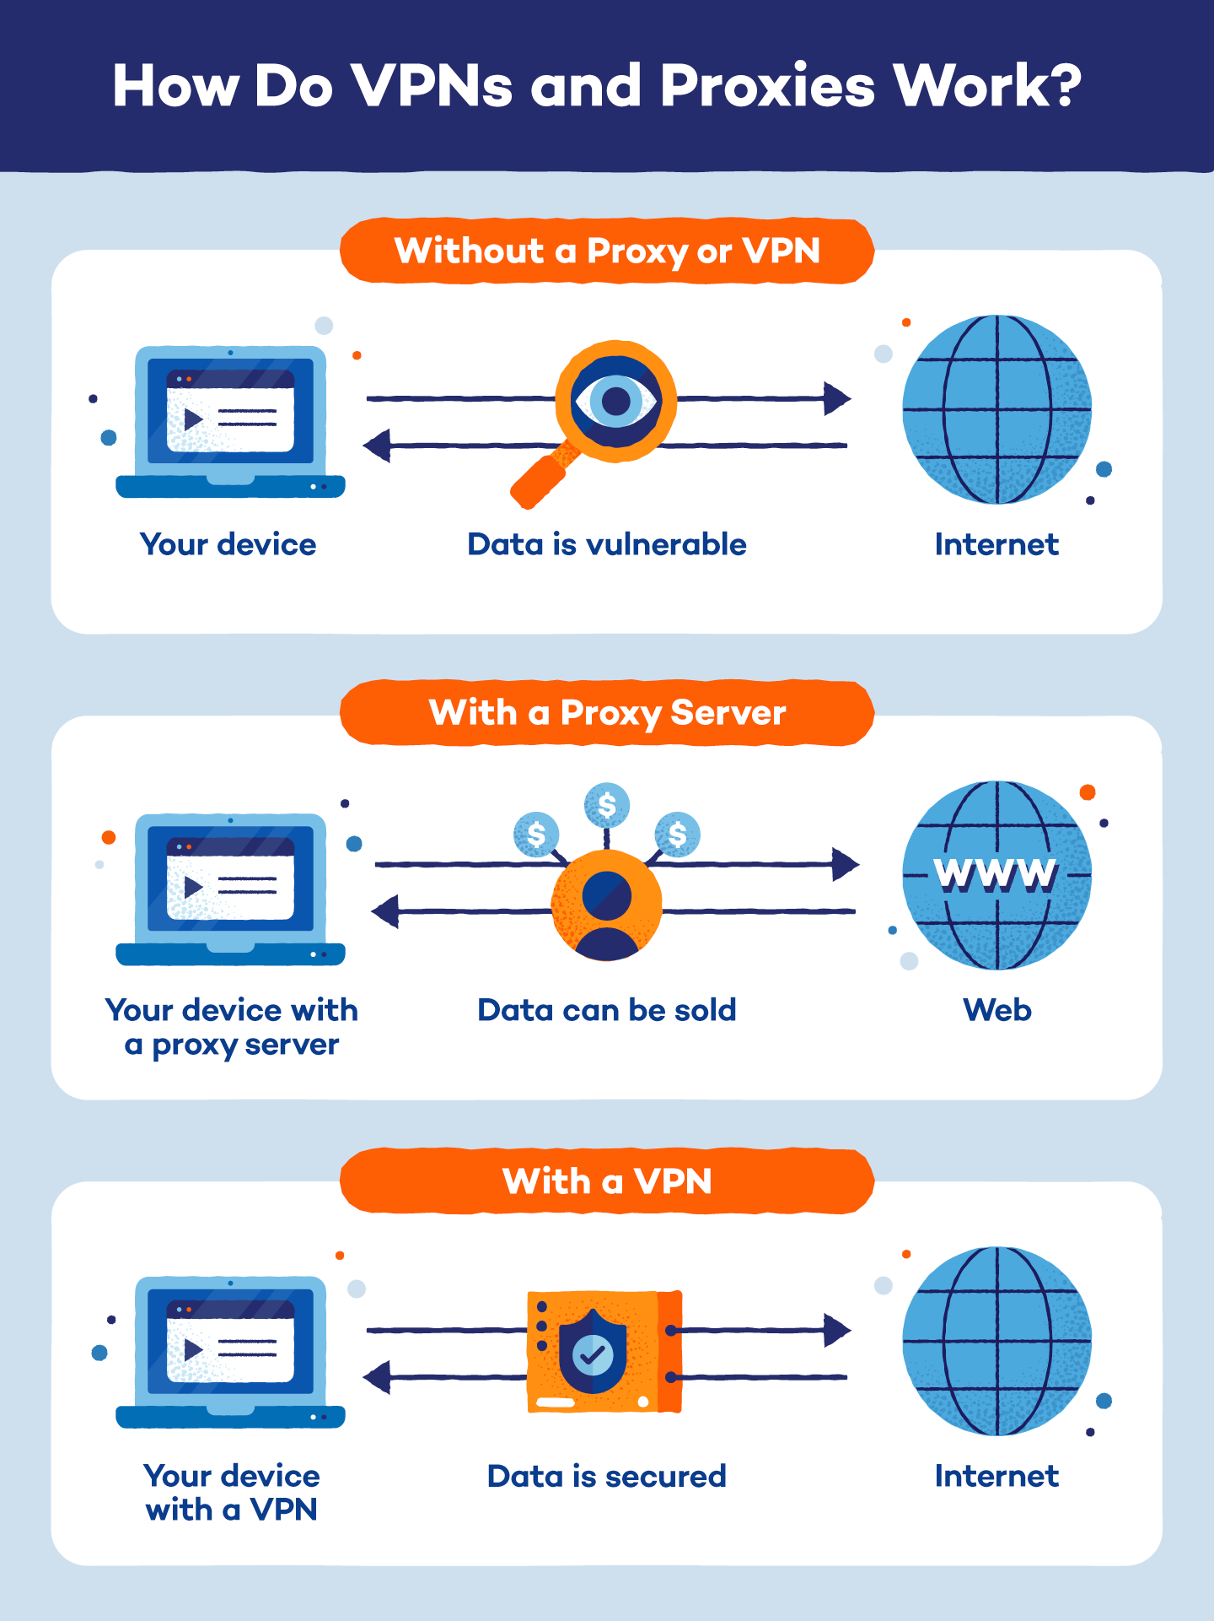

A proxy server and a VPN (virtual private network) are both tools that can enhance your online privacy and security, but they work in different ways. Here are the differences between them:

Proxy Server:

A proxy server acts as an intermediary between your browser and a special service.

It can store local copies of pages for quick access, alter or monitor information exchange, or speed up web communication.

To change your proxy server settings on a specific browser or PC, follow these steps:

Go to Settings (Preferences on Mac).

Click Browser in the sidebar.

Under Network, click the Change proxy settings button.

Enter the protocol (e.g., HTTP), web address (e.g., proxy.example.org or 192.0.34.166), and port number (e.g., 5000).

VPN (Virtual Private Network):

With a VPN, you connect to websites via a VPN server, which changes your apparent location to the location of the server.

It encrypts your connection, enhancing your privacy on the local network.

To enable VPN on a specific browser or PC, follow these steps:

In Opera, go to Settings.

In the sidebar, click Advanced, then click Privacy & security.

Under VPN, click Enable VPN.

You will now see the VPN button on the left side of the combined address and search bar. Click it to open the VPN pop-up window and turn on VPN.

From the pop-up window, you can also change your virtual location by selecting a region from the list.

I hope this helps! Let me know if you have any other questions.